# Important Questions of CMTS

1. **Explain in detail BIOS function.(Dec-15,May-15,Dec-14)**

**BIOS power-On Self Test (POST) OR List Out POST sequence in detail.**

* + The first thing that the BI0S do when it boots the pc is to perform what is called the Power- on Self-Test, or POST for short.
  + When the PC is first turned on, its main system memory is empty, and it needs to find instructions immediately to tell it what to run to start up the system. this it finds within the BI0S program which is stored on CMOS memory.

# System BOOT sequence(May-16)

1. The internal power supply turns on and initializes. The power supply takes some time until it can generate reliable power for the rest of the computer, Therefore, the chipset will generate a reset signal to the processor (the same as if you held the reset button down for a while on your case) until it receives the Power Good signal from the power supply.
2. When the reset button is released, the processor will be ready to start executing. When the processor first starts up, there is nothing at all in the memory to execute of course processor makers know this will happen, so that the processor always look for

preprogram. At the same place in the system BIOS ROM for the start of the BIOS boot program. this is normally location FFFF0h. This location just contains a “jump” instruction telling the processor where to go to find the real BIOS startup program.

1. The BIOS performs the power-on self test (POST). If there are any fatal errors, the boot process stops. POST beep codes can be found in this area of the Troubleshooting Expert.
2. The BIOS looks for the video card. In particular, it looks for the Video card’s built in

BIOS program and runs it. This BIOS is normally found at location c000h in memory. The system BIOS executes the video card BIOS, which initializes the video card' Most modern cards will display information on the screen about the video card.

1. The BIOS then looks for other devices' ROMs to see if any of them have BIOSes. Normally, the IDE/ATA hard disk BIOS will be found at C8000h and executed. If any other devices BIOSes are found, they are executed as well.
2. The BIOS displays its startup screen.
3. The BIOS does more tests on the system, including the memory count-up test which you

see on the screen. The BIOS will generally display a text error message on the screen if it encounters an error at this point.

1. The BIOS performs a "system inventory" of sorts, doing more tests to determine what sort of hardware is in the system' Modern BIOSes have many automatic settings and will determine memory timing (for example) based on what kind of memory it finds. Many BIOSes can also dynamically set hard drive parameters and access modes, and will determine these at roughly this time. Some will display a message on the screen for each drive they detect and configure this way. The BIOS will also now search for and label logical devices (COM and LPT ports).
2. If the BI0S support the Plug and Play standard, it will detect and configure plug and Play devices at this time and display a message on the screen for each one it finds.
3. The BIOS will display a summary screen about your system's configuration. Checking this page of data can be helpful in diagnosing setup problems, although it can be hard to see because sometimes it flashes on the screen very quickly before scrolling off the top.
4. The BI0S begins the search for a drive to boot from. Most modern BIOSes contain a setting that controls if the system should first try to boot from the floppy disk (A:) or first try the hard disk (C:). Some BIOSes will even let you boot from your CD-ROM drive or other devices, depending on the boot sequence BIOS setting.
5. Having identified its target boot drive, the BlOS looks for boot information to start the operating system boot process. If it is searching a hard disk. it looks for a master boot record at cylinder (), head(), sector 1 (the first sector on the disk) if it is searching a floppy disk, it looks at the same address on the floppy disk for a volume boot sector.
6. If it finds what it is looking for, the BlOS start the process of booting the operating system, using the information in the boot sector. At this point, the code in the boot sector takes over from the BIOS. If the first device that the system tries (floppy, hard disk, etc.) is not found, the BIOS will then try the next device in the boot sequence, and continue until it finds a bootable device.
7. If no boot device at all can be found, the system will normally display an error message and then freeze up the system.
8. This process is called a "cold boot" (since the machine was off, or cold, when it started). A “warm boot” is the same thing except it occurs when the machine is rebooted using

{Ctrl} + {Alt} + {Delete} or similar. In this case the POST is skipped and the boot

process continues roughly at step 8 above.

# BIOS Startup Screen

* + When the system BI0S starts up, you will see its familiar screen display, normally after the video adapter displays its information. These are the contents of a typical BIOS

start up screen:

1. The BIOS Manufacturer and Version Number.
2. **The BIOS Date:** The date of the BIOS can be important in helping you determine its capabilities.
3. **Setup Program Key:** The key or keys to press to enter the BIOS setup program. (This is usually {Del}, sometimes {F2}, and sometimes another key combination.
4. **System Logo:** The logo of the BIOS Company or in some cases the PC maker or motherboard manufacturer.
5. **The BIOS Serial Number:** This is normally located at the bottom of the screen. Since BIOSes are highly customized to the particular motherboard, this serial number can be used in many cases to determine the specific motherboard, this serial number can be used in many cases to determine the specific motherboard and BIOS version you are using.

# What are General faults of computer system(May-16)

The following list gives most general problem of computer.

* 1. The CPU has lost control
  2. There is a junk display on the monitor
  3. The printer prints suddenly
  4. The floppy disk drive always remains selected
  5. The CD drive always remains selected
  6. The hard disk drive is not reading data
  7. when types a character from keyboard, two or more characters are displayed on the monitor
  8. After power-on nothing is done by the computer, the computer is dead.
  9. The program is missing, memory contains junk.
  10. The program is getting aborted without any reason or message
  11. Computer display irrelevant error messages.
  12. Printer prints one line and immediately computer hangs.
  13. After power on, only the first program runs successfully. Subsequent programs aborted abnormally.
  14. If two Hard disk drives are connected, none of the Hard disk drive works properly. If any one of them is disconnected, everything is fine.
  15. Suddenly Hard disk drive gets erased
  16. Opening more than windows causes the system to hang
  17. Suddenly the display on the screen dances
  18. when the system covers are open, the computer works properly and when they are closed it misbehaves
  19. Keyboard not gives any response

CD ROM drives LED glow, but the CD is not read.

# Draw the layout of latest motherboard and explain the components mounted on motherboard in brief OR

**Draw & Explain the layout of motherboard(Dec-15,May-15,Dec-14)**

|  |
| --- |
|  |
| **Layout of Motherboard**   * A computer motherboard is nothing but the circuit board or the circuit which controls the entire functioning of the computer. * All the components that form your computer are connected to the computer   motherboard.   * The computer processor, which is the most important component of your computer, is mounted on the computer motherboard. * All other components like the computer keyboard, computer monitor, computer   mouse, hard drives. etc., are all connected to the computer motherboard through cables. |

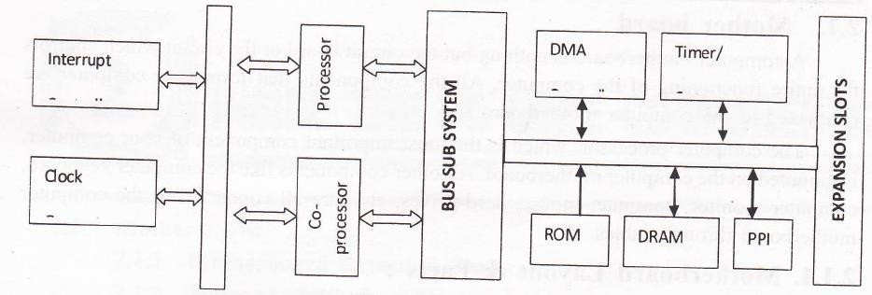

### Processor

**Block diagram of Motherboard**

* + - The processing unit of a computer is the component, which processes all those zeros and ones.
    - The higher the processing speed, the faster the system runs.
    - There are three main leading manufacturers of processors: Intel, AMD (American Micro Devices) and Cyrix.
    - The processor is a single integrated circuit (IC) containing sophisticated circuit that allows it to perform arithmetic functions.
    - The processor has two main sections: Bus Interface Unit (BUI) and Execution

Unit (EU).

* + - The BIU can transfer the data between the microprocessor and other circuit.
    - The EU is the part that carries out the instructions.
  1. **Co-processor**
     + The Co-Processor is an optional plug-in component on the motherboard.
     + The primary advantage of using this chip is the increased execution speed of program.
     + The coprocessor permits a computer to carry out certain operations much faster.
     + A coprocessor can make a computer run 5 to l0 times faster in some operation.
     + The processor works in conjunction with the co-processor when it is operating in the maximum mode.
     + Operations performed by the co-processor may be floating point arithmetic, graphics, signal processing, string processing, encryption or I/O Interfacing with peripheral devices

## Clock generator

* + - Computers are used clocked logic.
    - All the logic elements in the computer are designed to operate synchronously.
    - They carry out their designed operations one step at a time and each circuit makes one step at the same time.
    - This synchronous operation helps the machine to keep track of every bit that it can process.
    - These timing controls are generated by clock generator's logic.

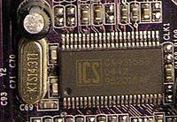

## A desktop PC clock generator, based on the chip ICS 952018AF and 14.3 MHz resonator (on the left)

* 1. **Bus Sub System**
     + This has latches to latch the address generated by the CPU on to the address buffer, transceivers to transfer data between processor and data bus, and bus controller to generate control signals.
     + The bus controller generates signal to control address latch, memory read,

memory write, I/O read and I/O write.

## Interrupt Controller

* + - Interrupts are generated to capture the microprocessor's attention and temporarily divert it to a different process.
    - The interrupt controller handles 8 maskable interrupts.
    - The interrupt request lines are designated with numbers 2 to 7 with decreasing priority.
    - The Non-maskable interrupt (NMI) logic generates the NMI signal. It is generated on detection of

l) RAM parity error in motherboard

1. RAM parity error in daughter boards which have the RAM as expansion memory
2. Co-Processor error if coprocessor is installed

## ROM and RAM Logic

* + - The PC memory is a block where any byte of information is directly available by calling its address.
    - The ROM stores the POST (Power On Self Test) and BIOS.
    - The use of dynamic RAM in PC needs refreshing the memory.
    - The DMA channel 0 is used for it.

## Direct Memory Access Controller (DMA Controller-8237)

* + - To speed up the system performance the main processor is to be relieved from time consuming jobs like moving blocks of memory (bulk data) between main memory and I/O devices.
    - The DMA controller handles these tasks separately.
    - Once it receives instructions from the CPU the DMA takes the command and does all the memory transfer operations.

## Timer/counter Logic ( Programmable Interval timer 8253)

* + - There are main three timers on motherboard.
    - Time 0 : Used to interrupt the processor at the rate of 18.2 clock cycle per second to maintain the system time and date
    - Time 1: Used to generate DMA request signals for performing refresh cycles at every 15 microseconds.
    - Time 2: Used to generate various tones by the speaker.

## Peripheral Interface Logic (PPI-8255A)

* + - The programmable peripheral interface (PPI) device connects the peripheral devices to the personal computer system.
    - It is design to implement parallel I/o ports without the additional circuit.
    - The PPI is very flexible parallel interface that is software controlled.
    - Earlier PC's had the keyboard connected to PPI.
    - Recent models have a separate microcontroller such as 8042 for connecting mouse and keyboard with computer system.

# Explain in detail logical structure of Hard disk.(Nov-2014,May-2015)

Following are the major logical part of the Disk:

* Sides or Heads
* Tracks
* Cylinder
* Sector
* Zone
  1. **Sides or Heads-** Drive with three platters one can read and write on six sides. If the drive is servo based then one side may be used for the servo information and only 5 usable sides will be available. This type of drive used in early system. Each side of the disk has a separate read/write head to read/write on the disk surface.

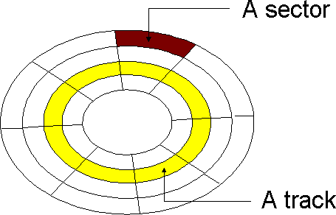

* 1. 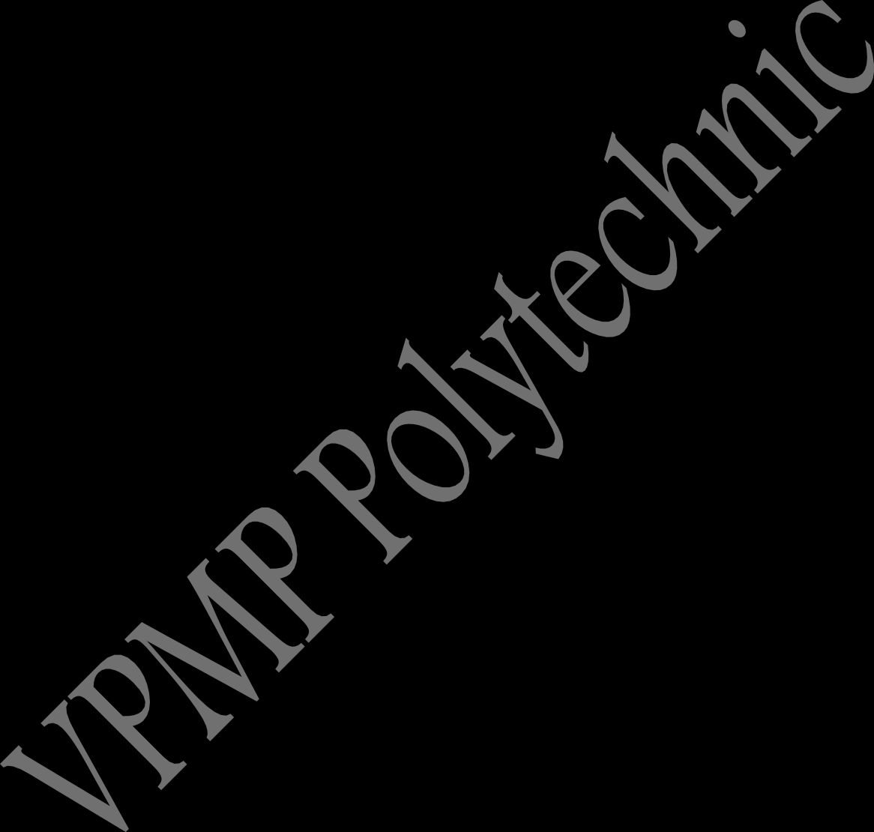**Tracks -** Each side of the hard disk drives platter’s surface is divided into concentric circles called tracks as shown in above fig. Each track is identified by its number.
     + The outer most tracks are given track number 0 the next one 1 and so on. The inner most track have the highest track number. The numbers of tracks are depending on the hard disk manufacturer. Generally there are 300 to 500 in range. Typically disk with more tracks may give more hard disk data storage capacity.
  2. **Cylinder –** The hard disk having more than one platter makes virtually a cylinderlike structure on same tracks of different platters as shown in figure.

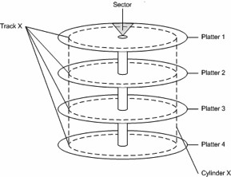

For example the track i on the all the platter is make a cylinder i. The data is stored cylinder by cylinder on the disk. First all the tracks of same cylinder are written. Once a cylinder becomes full the read/write head moves to the next cylinder for writing data.

## These logically divide the disk in cylinder gives following advantages:

1. When the read/write head is moved to a specific cylinder all the heads are on the same track, so that it is faster to write on this particular track on all the sides.

For example disk having six heads, when the head 0 is moved to track 4, all the other heads also move to track number 4 on their respective sides. Writing on this particular track on all the 6 sides is faster, compared to moving the head to next track and continue writing on each of sides.

1. This method of writing on the complete cylinder before moving the head to next cylinder reduces the read/write head movement, which improve speeds of read/write data operation on disk. Because the maximum time is

wasted in read/write head movement while writing the data on disk.

## Sector -

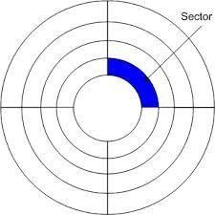

* + - The tracks are dividing further which is called the sector. During the formatting of the hard disk, the formatting program divides the disk surface into different sector by writing magnetic pattern on the disk surface. Different capacity of hard disk drive divides the track into different number of sectors 17 to 100 or more sectors per track are very common.
    - As a standard on almost all the drives are stored 512 bytes on each sector.
    - The sector always starts with the number one while the track and cylinder are start with zero.

## Interleave:

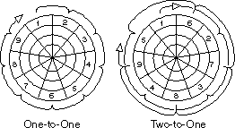

* System hardware and software may not be fast enough to read or write a series of sectors consecutively. This is especially in the case of earlier disk drives.
* For example, after writing 1 sector the data for the next sector may not be

in the buffer yet, and so cannot be written into the adjacent sector. The disk in this case would interleave the sectors so that sufficient time is given for the data to be ready by skipping the next one or two sectors as shown in fig.

### Zone –

* + - When we logically divide the disk in tracks and sector, due to circular shape the outer track or the outer cylinder has much more area compared to the inner track of the disk drive.
    - Allocating same number of sectors in the outer as well as inner track of the drive is a waste of the storage capacity of the disk drive. The outer tracks have larger area compare to inner tracks, it can be easily divide more sector compare to inner one. if we do that the storage capacity of the disk is become larger.
    - A new recording system called Zone bit Recording is used by the currently high capacity IDE and SCSI hard disk drives to store more number of sectors in the outer tracks compared to the number of sectors in the inner tracks. Each zone will have a fixed number of sectors per tracks.
    - The outermost zone will have maximum number of sectors per track and the inner

most zone will have minimum number of sectors per track.

### Zone Bit Recording-

* + - Zone Bit Recording (ZBR) is used by disk drives to store more sectors per track on outer tracks than on inner tracks. It is also called Zone Constant Angular Velocity**.**

### MBR-

* + - A master boot record (MBR) is a special type of boot sector.
    - The MBR holds the information on how the logical partitions, containing file systems, are organized on that medium.

### Cluster-

* + - Each partition on your hard disk is subdivided into clusters. A cluster is the smallest possible unit of storage on a hard disk.
    - The size of a cluster depends on two things:

1. The size of the partition

## Components of Hard Disk Drive

* + - The basic components of a typical hard disk drive are as follows
      * Disk platters
      * Read/write heads
      * Head actuator mechanism
      * Spindle motor (inside platter hub)
      * Logic board (controller or Printed Circuit Board)
      * Cables and connectors

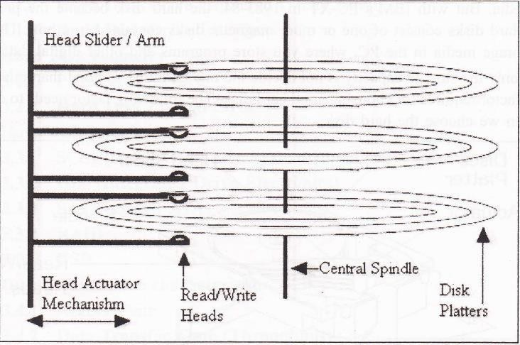

**Configuration items**

1. **Disk Platters :**

* All hard disks consist of thin platters with a magnetic coating.
* They rotate quite fast inside a metal container.
* Data are written and read by read/write heads, which are designed to ride on a microscopic cushion of air, without touching the platter. They register bits from the magnetic coating.
* A hard disk with three platters is shown in figure.
* Generally the hard disk has minimum 1 platter and maximum up to 10 (even more possible) depend on the hard disk manufacturer.

## Spindle Motor :

* The disk platters are connected to one central spindle, which is directly connected to the main spindle motor.
* Most of the Hard disk drive spindle motor is located at the bottom of the drive.
* Spindle motor gives circular rotation to the platters for Read/Write operation on specific location.
* On some drives the spindle is connected to the spindle rotation motor through some belt or gears. This motor works on a feedback loop to automatically adjust the disk's rotation speed.
* To use more platters in Hard disk drive the spindle, motor is directly built into the platter hub inside the sealed assembly. This will allow adding more platters in hard disk drive because the spindle motor does not take any

additional vertical space.

## Read/Write Head

* As shown in above with 3 platters, it has 6 read/write heads, two heads for every one platter, which move synchronously the arms which guide the movement of the read/write heads move in and out.
* These heads do not require cleaning or any other maintenance, as the floppy drive heads because these heads do not touch the disk surface instead it floats a distance above the disk surface during the read/write process. When specifying the head number for reading or writing any information onto the disk drive. The first head is specified as head 0 next 1 so on.
* The synchronous movement of these arms is performed by an electro- mechanical system called the head actuator.
* When the disk rotates under the read/write head it can either read existing data or write new ones.
* In write mode, current is applied to the coil the head will become magnetic.
* This magnetism will orient the micro magnets in the track.
* If the head moves along the track without current applied to the coil, it will sense the micro magnets in the track.
* This magnetism will induce a current in the coil. These flashes of current

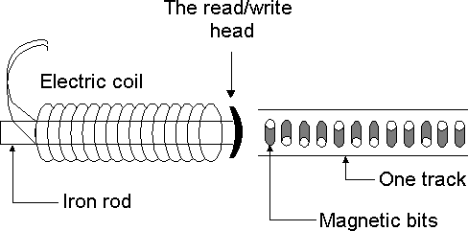

represent the data on the disk. This is read mode.

## Head Actuator Mechanism:

* To moving read/write head of the Hard disk drive on the disk platters is referred as Head Actuator Mechanism.
* There are two type of Head Actuator Mechanism
  1. **Stepper Motor Actuator (Open-loop disk drive)-** A stepper motor rotates in fix angle with each step. Earlier low capacity, low cost Hard disk drive used this type of Actuator assembly to move read/write head.
* **Voice Coil Actuator (Closed-loop disk drive)-** The actuator in a modern hard disk uses a device called a voice coil to move the head arms in and out over the surface of the platters, and a closed-loop feedback system called a servo system

# Explain Motherboard Types/Form Factors (AT, Baby AT, ATX, LPX, NLX, BTX)

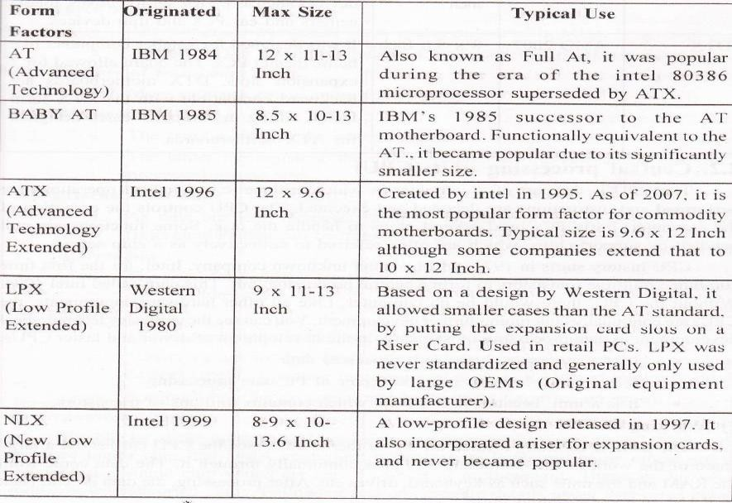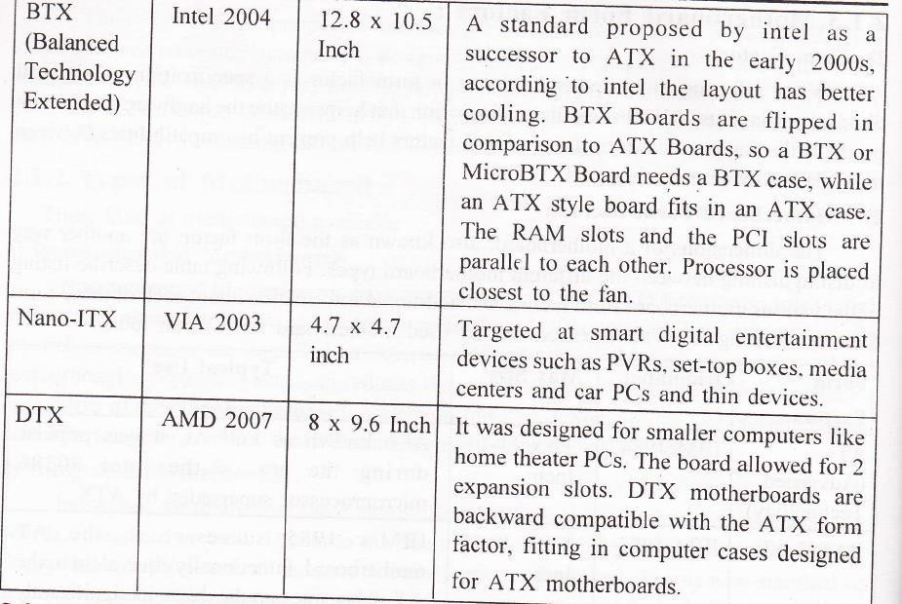

1. **Explain in detail North Bridge & South Bridge.(Dec-15,May-15,Dec-14)**

### North Bridge:

* A Northbridge or host bridge is a microchip on some PC motherboards and is connected directly to the CPU (unlike the Southbridge) and thus responsible for tasks that require the highest performance.
* The Northbridge is usually paired with a Southbridge, also known as I/O controller hub.
* In systems where they are included, these two chips manage communications between the CPU and other parts of the motherboard, and constitute the core logic chipset of the PC motherboard.

The Northbridge typically handles communications among the CPU. in some

cases RAM, and PCI Express (or AGP) video cards, and the Southbridge.

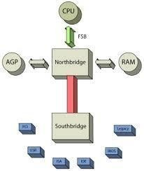

* Some Northbridge also contain integrated video controllers, also known as Graphics and Memory Controller Hub (GMCH) in Intel system.
* Because different processors and RAM require different signaling, a given Northbridge will

typically work with only one or two classes of CPU’s and generally only one type of RAM. **South Bridge:**

* The South Bridge is one of the two chips in the core logic chipset on a personal computer (PC) motherboard, the other being the North Bridge.
* The South Bridge typically implements the slower capabilities of the motherboard in a North Bridge/South Bridge chipset computer architecture.
* The South Bridge can usually be distinguished from the North Bridge by not being directly connected to the CPU rather the North Bridge ties the South Bridge to the CPU.
* Through the use of controller integrated channel circuitry, the North Bridge can directly link signals from the I/O units to the CPU for data control and access.

A south bridge chipset handles all of a computer's I/O functions such as USB,

audio, serial, the system BIOS, the ISA bus, the interrupt controller and the IDE channels.

# Explain in detail different types of Memory

### Static Memory:

* + This memory approaches assume that the addresses don't change.
  + The static memory allocation may be through absolute addresses or through PC relative addresses, but in either case the compiler or assembler generates a set of addresses that cannot change for the life of a program or process.

### Dynamic Memory:

* + These approaches assume that the addresses can change.
  + The two most common dynamic approaches are the use of stack frames and the use of pointers or handlers.
  + Stack frames are used primarily for temporary data. Handles and pointers are used for keeping track of dynamically allocated blocks of memory.

**Permanent Memory (Non-Volatile)-** Examples of non-volatile memory include:

### ROM

* + **PROM**
  + **EPROM**
  + **EEPORM**

1. **Flash Memory**
2. **Computer Storage Devices**
   * **Hard Disk**
   * **Floppy Disk**
   * **CD-RW**
   * **DVD**
   * **ZIP**

**Drive.**

* + **ROM(Read Only Memory)**
* ROM is typically used to store things that will never change for the life of the computer such as low level portions of an operating system.
* Some processors might have RAM and/or ROM built into the same chip as the processor, normally used for processors used in standalone devices, such as arcade video games, ATMs, microwave ovens, car ignition systems, etc.
* Computers almost always contain a small amount of read-only memory that holds instructions for starting up the computer.

**PROM (Programmable Read Only Memory) :**

* + A PROM is a memory chip on which data can be written only once.
  + Once a program has been written onto a PROM it remains there forever.
  + Unlike RAM, PROM's retain their contents when the computer is turned off.
  + The difference between a PROM and a ROM (read-only memory) is that a PROM is manufactured as blank memory, whereas a ROM is programmed during the manufacturing process.
  + To write data onto a PROM chip, you need a special device called a PROM programmer or PROM burner.
  + The process of programming a PROM is sometimes called burning the PROM.

## EPROM (Erasable Programmable Read-Only Memory)

* + EPROM is a special type of PROM that can be erased by exposing it to ultraviolet light.
  + Once it is erased, it can be reprogrammed.
  + An EEPROM is similar to a PROM, but requires only electricity to be erased.

## EEPROM (Electrically Erasable Programmable Read-Only Memory)

* + EEPROM Pronounced double-ee-prom or e-e-prom, an EEPROM is a special type of PROM that can be erased by exposing it to an electrical charge.
  + Like other types of PROM, EEPROM retains its contents even when the power is turned

off.

* + Also like other types of ROM, EEPROM is not as fast as RAM. EEPROM is similar to flash memory (sometimes called flash EEPROM).
  + The principal difference is that EEPROM requires data to be written or erased one byte at a time whereas flash memory allows data to be written or erased in blocks. This makes memory faster.

## Flash Memory

* + This is a solid-state, nonvolatile, rewritable memory that functions like RAM and a hard disk combined integrated with a USB (Universal Serial Bus) interface
  + If power is lost, all data remains in memory.
  + Because of its high speed, durability, and low voltage requirements, it is ideal for

digital cameras, cell phones, printers, handheld computers pagers and audio recorders.

* + SB flash drives are typically removable and rewritable, and physically much smaller than a floppy disk.

## Temporary Memory-Random Access Memory (RAM)

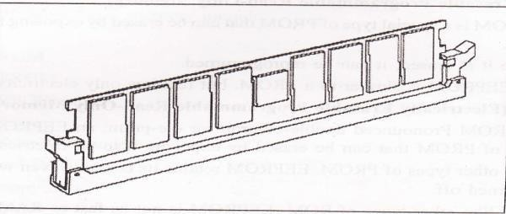

* + Also known as Volatile Memory.
  + Volatile memory is computer memory that requires power to maintain the stored information. Most modern semiconductor volatile memory is either Static RAM (SRAM) or dynamic RAM (DRAM).
  + RAM is Random Access Memory, and is the basic kind of internal memory.
  + RAM is called "random access" because the processor or computer can access any location in memory.
  + RAM has been made from reed relays, transistors, integrated circuits. Magnetic core or anything that can hold and store binary values.
  + Most modern RAM is made from integrated circuits.
  + Static R/.M is called static because it will continue to hold and store information even when power is removed. Magnetic core and reed relays are examples of static memory.
  + Dynamic RAM is called dynamic because it loses all data when power is removed.
  + Transistors and integrated circuits are examples of dynamic memory.
  + It is possible to have battery backup for devices that are normally dynamic to turn them into static memory.

## Cache Memory(What is Cache Memory? explain memory caching & disk caching)

* + Pronounced cash, a special high speed storage mechanism.
  + It can be either a reserved section of main memory or an independent high speed storage device.
  + Two types caching are commonly used in personal computers.
  + Memory Caching & Disk Caching

## Memory Caching:

* + A memory cache, sometimes called a cache store RAM cache, is a portion of

memory made of high speed static RAM (SRAM) instead of the slower and cheaper dynamic RAM (DRAM) used for main memory.

* + Memory caching is effective because most programs access the same data or

instruction over and over.

* + By keeping as much of this information as possible in SRAM, the computer avoids accessing the slower DRAM.
  + Some memory caches are built into the architecture of microprocessors. The Intel 80486 microprocessor, for example, contains an 8K memory cache, and the Pentium has a 16K cache. Such internal caches are often called Level 1 (L1) caches.
  + Most modern PCs also come with external cache memory, called Level 2 (L2) caches. These caches sit between the CPU and the DRAM.
  + Like L1 caches, L2 caches are composed of SRAM but they are much larger.

## Disk Caching:

* + Disk caching works under the same principle as memory caching, but instead of using hugh- speed SRAM.
  + A disk cache used conventional main memory.
  + The most recently accessed data from the disk (as well as adjacent sectors) is stored in a memory buffer. When a program needs to access data from the disk, it first checks the disk cache to see if the data is there.
  + Disk caching can dramatically improve the performance of applications, because accessing a byte of data in RAM can be thousands of times faster than accessing a byte on a hard disk.

Many cache system use a technique known as smart caching, in which the system can recognize certain types of frequently used data.

## System Memory(Dec-15)

### Dual Inline Package (DIP)

* + Early versions of RAM were installed as single chips, usually l-bit-wide DIP (dual inline package)
  + In some cases, this was soldered right onto the motherboard, but most often it was seated in a socket, offering a simpler method of removal and replacement.

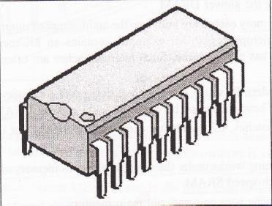

* + As the amount of memory and the need for speed increased, manufacturers started to market modules containing several chips that allowed for easier installation and larger capacity.
  + These modules come in a variety of physical configurations.

## ZIP

* + The Zip drive is a medium-capacity removable floppy disk storage system that was introduced by Iomega in late 1994.
  + Originally, Zip disks launched with capacities of 100 MB, but later versions increased this to first 250 MB and then 750 MB.
  + They are stable, inexpensive, and easy to work with.

## Single Inline Pinned Package (SIPP)(Dec-15)

* + One of the first module forms of DRAM, the SIPP (single inline pinned package) is a printed circuit board with individual DRAM chips mounted on it.
  + 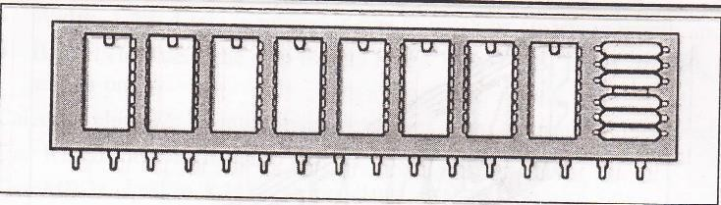SIPP module looks like a rectangular card with a single row of pins along one edge.

## Single Inline Memory Modules (SIMM 30-pin)(Dec-15)

* + SIMMs (single inline memory modules) quickly replaced SIPPs because they are easier to install.
  + They are similar to SIPPs with one exception, they require no pins.
  + 30-pin SIMMs has 30 contacts in a single row along the lower edge.
  + A 30-pin SIMM can have as few as two or as many as nine individual DRAM chips.
  + Although SIMM modules can have pin counts as high as 200, in PCs, 30-pin and 72-pin versions are the most common.
  + A typical motherboard of the time offered four SIMM sockets capable of taking

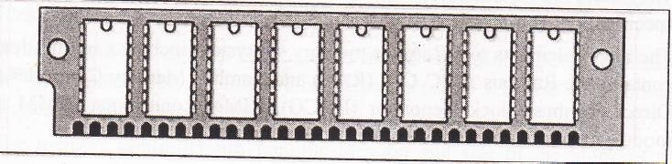either single- sided or double-sided SIMMs with module sizes of 4, 8, l6,32 or even 64MB.

## Dual Inline Memory Modules (DIMM)

* + As memory subsystems standardized around an 8-byte data interface, the Dual Inline Memory Module (DIMM) had replaced the SIMM as the module standard for the PC industry.
  + DIMMs have 168 pins in two (or dual) rows of contacts, one on each side of the card.
  + 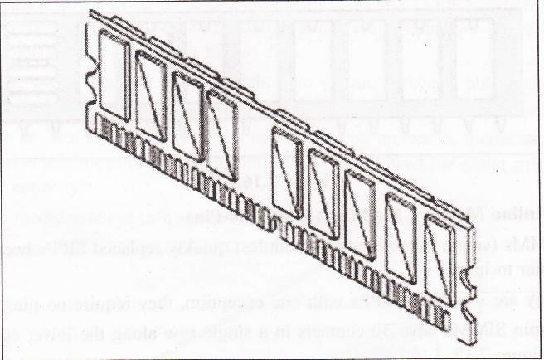With the additional pins a computer can retrieve information from DIMMs, 64 bits at a time instead of the 32-bit or l6-bit transfers that are usual with SIMMs.

## RIMM

* + The name is not an acronym, but a trademark of Rambus Inc.
  + RIMM connectors have a form factor similar to DIMMs and fit within the same board area as the footprint for a DIMM connector.
  + They have 184 pins compared to a DIMM's 168, but use the same socket specification as a standard 100MHz DIMM.
  + The major elements to a Rambus memory subsystem include a master device that contains the Rambus ASIC Cell (RAC) and Rambus Memory Controller (RMC), Direct Rambus Clock Generator (DRCG), RIMM connectors, RIMM memory modules, and RIMM continuity modules.

## Dynamic RAM (DRAM)

* + DRAM chips are large, rectangular arrays of memory cells with support logic that is used for reading and writing data in the arrays, and refresh circuitry to maintain the integrity of stored data.
  + Memory arrays are arranged in rows and columns of memory cells called word lines and bit lines, respectively.
  + Each memory cell has a unique location or address defined by the intersection of a row and a column.
  + DRAM is cheaper than SRAM and uses half as many transistors.
  + When speaking of DRAM SIPPs and SIMMs, we use two values to determine how much memory a unit can hold
  + **Width** 1 bit, 4 bits (a nibble), 8 bits (a byte), or 16 bits (a word), and so on.
  + **Depth** How deep the chip is: 256 KB, 1 MB, 4 MB, 8 MB, 16 MB,32 MB and so on.
  + Calculate chip size by multiplying depth by width; the result is measured in bits.
  + One KB of memory is equal to 8l92 bits (1024 * 8).
  + One MB is equal to 8,388,608 bits (1024*1024*8).

## SDRAM

* + This key feature of SDRAM gives it an important advantage over other, asynchronous memory types, enabling data to be delivered off-chip at burst rates of up to 100MHz
  + Once the burst has started all remaining bits of the burst length are delivered

at a 10ns rate.

* + With SDRAM an on-chip burst counter allows the column part of the address to be incremented very rapidly which helps speed up retrieval of information in sequential reads considerably.

1. 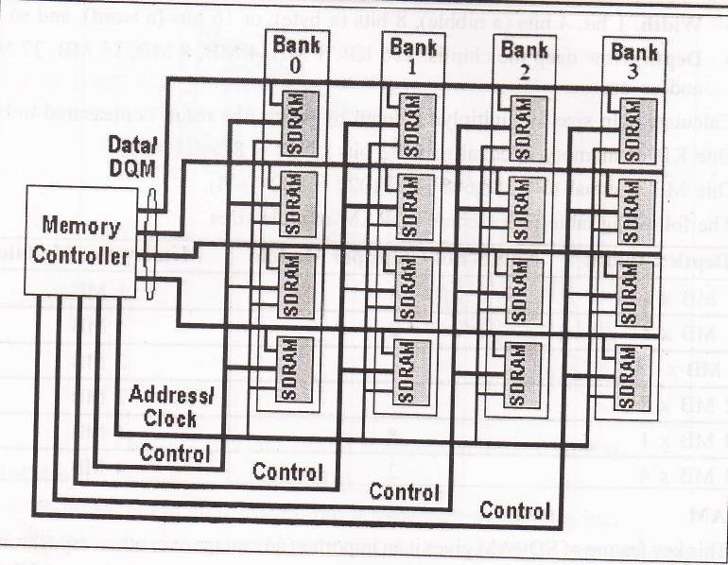**DDR SDRAM**
   * Traditionally, to synchronize logic devices, data transfers would occur on a clock edge.
   * As a clock pulse oscillates between 1 and 0, data would be output on either the rising edge (as the pulse changes from a 0 to a 1) or on the falling edge.
   * DDR DRAM works by allowing the activation of output operations on the chip to occur on both the rising and falling edge of the crock, thereby providing an effective doubling of the clock frequency without increasing the actual frequency.
   * DDR memory chips are commonly referred to by their data transfer rate. This value is calculated by doubling the bus speed to

reflect double data rate.

## SLDRAM (Synchronous-Link DRAM)

* + SLDRAM boasted higher performance and competed against RDRAM.
  + SLDRAM was an open standard and did not require licensing fees.
  + The specifications called for a 64-bit bus running at a 200, 300 or 400 MHz clock frequency.
  + This is achieved by all signals being on the same line and thereby avoiding the synchronization time of multiple lines.

## DRDRAM (Rambus Dynamic Random Access Memory)

* RDRAM (Rambus Dynamic Random Access Memory) is a memory subsystem that promises to transfer up to 1.6 billion bytes per second.
* The subsystem consists of:
* Random access memory GAM),
* RAM controller
* Bus (path) connecting RAM to the microprocessor
* Devices in the computer that use it.
* Direct Rambus (DRDRAM), a technology developed and licensed by the Rambus Corporation, is the latest version and is expected to help accelerate the growth of visually intensive interfaces such as 3-D, interactive games, and streaming multimedia.
* Rambus is intended to replace the current main memory technology of dynamic random access memory DRAM).
* The components that are inserted into motherboard connections are

called Rambus in-line memory modules (RIMMs). They can replace conventional dual in-line memory module.

## FPM (Fast Page Mode) DRAM

* All types of memory are addressed as an array of rows and columns, and individual bits are stored in each cell of the array.
* With standard DRAM or FPM DRAM, which comes with access times of 70ns or 60ns, the memory management unit reads data by first activating the appropriate row of the array, activating the correct column, validating the data and transferring the data back to the system.
* The column is then deactivated, which introduces an unwanted wait state

where the processor has to wait for the memory to finish the transfer.

* The output data buffer is then turned off, ready for the next memory access.
* FPM can achieve a burst rate timing as fast as 5-3-3-3. This means that reading the first element of data takes five clock cycles, containing four wait-states, with the next three elements each taking three.
* DRAM speed improvements have historically come from process

and photolithography advances.

## EDO (Extended Data Out) DRAM

* Extended Data Out DRAM comes in 70ns, 60ns and 50ns speeds. 60ns is the slowest that should be used in a 66MHz bus speed system (i.e. Pentium l00MHz and above).
* EDO DRAM doesn't demand that the column be deactivated and the output buffer turned off before the next data transfer starts.

# Explain in detail printer interface

* Printers are connected to computers using a variety of different interfaces such parallel, serial, SCSI, USB or IEEE 1394.
* Network capable printers also have a built-in network interface and are connected directly to a port on the network so they can be shared across many computers.

# Parallel

* A parallel printer interface is called (IEEE 1284).
* This port works by sending an 8-bit information stream to the printer. It uses a standard parallel printer cable, which has a DB-25 connector to connect to the computer and also a 36-pin Centronics connector for the connection to the printer.
* The maximum length of the parallel cable is usually limited to 10 feet.
* The reason for this is that the data integrity decreases, and you can have loss of data to the printer over a larger length.

# Serial

* The serial printer interface sends the data to the printer one bit at a time.

This interface needs to be configured to the serial communication parameters including baud rate, parity bit, or start and stop bits.

* + 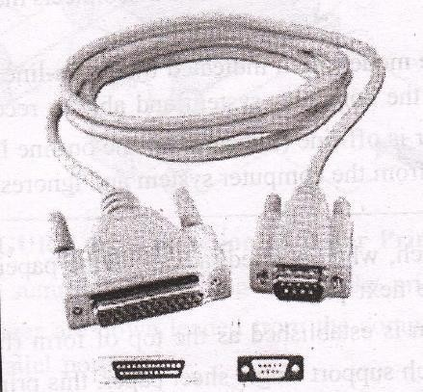Serial printers are very rarely used these days, however sometimes dot matrix printers use this interface.

**1) Universal Serial Bus (USB**)

* + The USB port is the most common type of port available on most pc today.
  + This is why it makes a great printer interface used on small and medium sized printers and desktop printers and scanners combos.
  + USB is much faster than most of the other types of printer interfaces.
  + A USB printer comes with Plug and play compatibility and can be automatically detected and configured by your operating system.

**2) IEEE**

**1394**

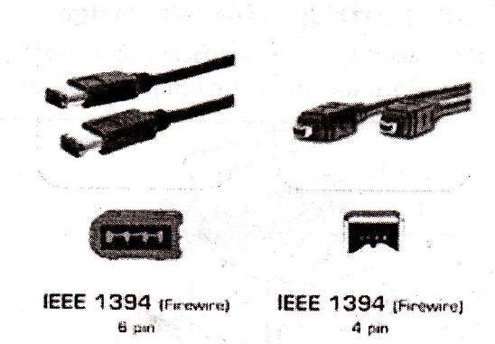

•

* + The IEEE 1394, which is also called Firewire, due the super fast speed that it boasted at when it was first released.
  + The firewire interface is not built in though on many printers or pc.

It is available for high end printers, and is popular on laptops.

### Explain in detail Different types of keyboard interfaces. OR

**Explain in detail different types of keyboard interface connector.**

* + The keyboard connector is the device at the end of the cable that is used to attach the keyboard to the system.

**Wired keyboard**

## DIN

**PS/2**

* The older style is the larger of the two, called the 5-pin DIN keyboard connector.
* DIN stands for Deutsche Industries Norm, a German standards-setting organization.
* 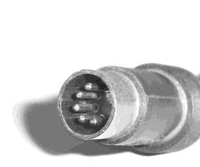It was used on the first PCs, and became the standard connection through about the mid- 1990s.

|  |  |  |
| --- | --- | --- |
| **Pin** | **Description** | **Image** |
| 1 | Keyboard  Clock |  |
| 2 | Keyboard Data |
| 3 | Not Connected |
| 4 | Ground |
| 5 | Power (+5 V) |
| 6 | - |

* The smaller is the 6-pin, so-called "mini-DIN" keyboard connector.
* The smaller connector was introduced on the IBM model PS/2 and is therefore

sometimes called a "PS/2 connector".

* + It has replaced the larger connector as the standard for modern PCs.

|  |  |  |
| --- | --- | --- |
| **Pin** | **Description** | **Image** |
| 1 | Keyboard Data |  |
| 2 | Not Connected |
| 3 | Ground |
| 4 | Power (+5 V) |
| 5 | Keyboard Clock |
| 6 | Not Connected |

## USB

* USB, or Universal Serial Bus, is the most common type of interface and has become the standard interface on all current computers.
* One of the benefits of a well-defined specification like the USB is the abundance of device drivers available in most modern operating systems.
* Because of these generic descriptions, it is easy for operating system designers to include functioning drivers for devices such as keyboards, mice, and other generic human interface devices.

|  |  |  |
| --- | --- | --- |
| **Pin** | **Description** | **Image** |
| 1 | Power (+5 V) |  |
| 2 | Data - |
| 3 | Data + |
| 4 | Ground |

**Wireless Keyboard**

* A wireless keyboard is a computer keyboard that allows the user to communicate with computers, tablets, or laptops with the help of radio frequency (RF), infrared (IR) or Bluetooth technology.
* Wireless keyboards based on infrared technology use light waves to transmit signals to other infrared-enabled devices.
* But, in case of radio frequency technology, a wireless keyboard communicates using signals which range from 27 MHz to up to 2.4 GHz.
* Most wireless keyboards today work on 2.4 GHz radio frequency.
* Bluetooth is another technology that is being widely used by wireless keyboards.
* These devices connect and communicate to their parent device via the Bluetooth protocol.
* A wireless keyboard can be connected using RF technology with the help of two parts, a transmitter and a receiver.
* The radio transmitter is inside the wireless keyboard.
* The radio receiver plugs into a keyboard port or USB port.
  + Once the receiver and transmitter are plugged in, the computer recognizes the keyboard and mouse as if they were connected via a cable.

# Explain in detail different types of Keyboard

1. **PC-XT Keyboard**

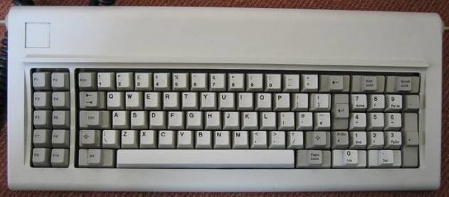

* This keyboard has only one side communication. The keyboard can send information to the system but the system was not allowed to send any information or command to the keyboard.
* Number of Keys: 83
* Mode of Communication: Unidirectional
* Size of Enter and Shift keys were small.
* Keys were marked with arrows instead of word describing them
* No indicators to show status of num_lock, caps_lock and scroll_lock

### PC-AT Keyboard

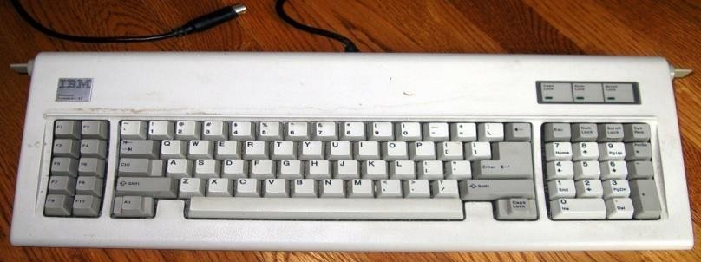

* Number of Keys: 84
* Mode of Communication: Bidirectional
* Numeric keypad moved away from alphabet keys
* Indicators available to show status of num_lock, caps_lock and scroll_lock
* Size of Enter and Shift keys is increased and word “Enter” is printed on the key top.
* Most of the keys that were indicated only with arrow symbols were also indicated with sort word describing them.

### Enhanced PC-AT Keyboard

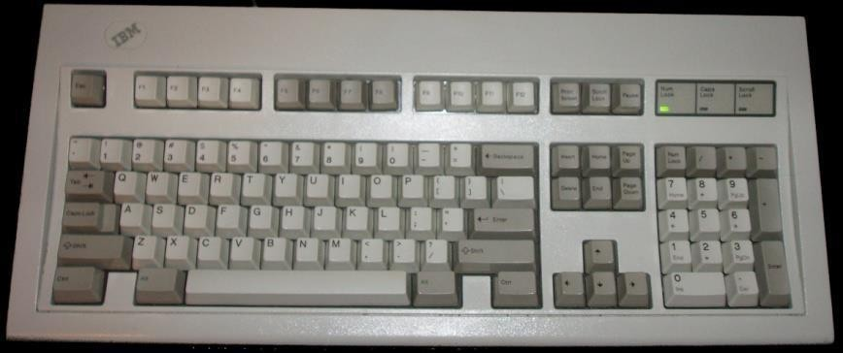

* Number of Keys: 101
* Additional navigation and control keys
* 12 function keys in separate row along top were provided
* The size of “Enter” key is reduced to a small size

Provided additional CTRL and ALT keys on both sides of space bar for easy access